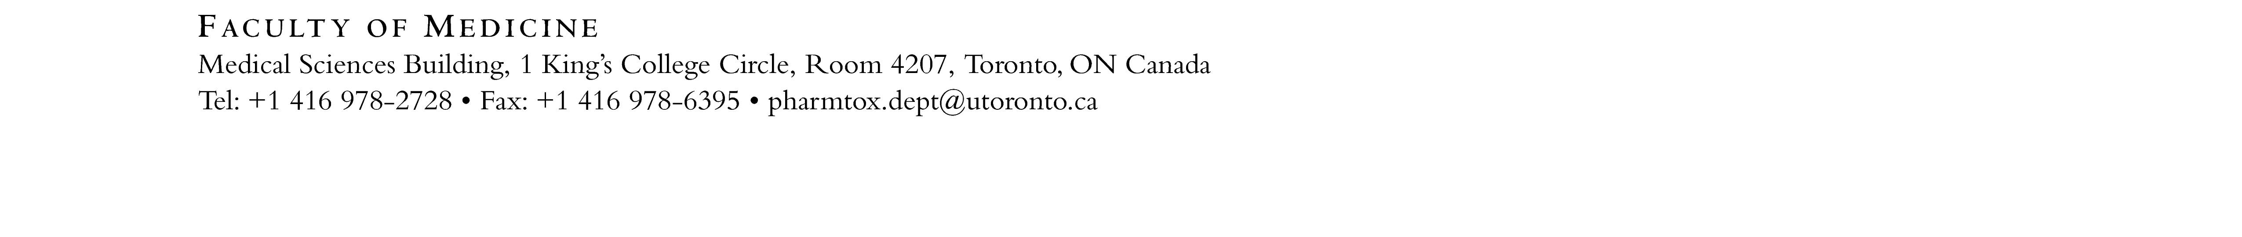

Laboratory Demonstrator Application Form 2019-2020

Please return the completed form along with a cover letter and a copy of your résumé to undergrad.pharmtox@utoronto.ca.

Please note that students can hold Teaching Assistantship in 1 lecture-based course and/or 1 laboratory-based course.
A separate application is required for lecture-based courses and invigilation.

Applicant Name: |  | Email Address:
Home Phone: |  | Work Phone:
University Address:

Department: |  | Program:  Undergrad MSc PhD PDF
Year in Program (as of September 2019): |  | Current Supervisor:
What is your background experience in Pharmacology and/or Toxicology? Please include relevant coursework.

Which of the following techniques are you familiar with? Please check all that apply:

Cell culture techniques | Trypan Blue assay |  | MTS assay
Alamar Blue assay | DNA, protein and RNA isolation |  | Western blot
qPCR, PCR | Restriction enzyme digest |  | Flow cytometry
BRET assay | PDE activity assay |  | Liver microsomes preparation
Data analysis by HPLC | Mouse handling: i.p. injection, saphenous vein bleeding, blood plasma processing |  | Pharmacokinetics in mice and/or in human – data quantification by HPLC
Genotyping | Drug metabolism |  | Behavioral testing in mice-locomotor activity and elevated plus maze
Human behavioural studies – questionnaire and battery of human behavioural tests | Good understanding of statistical data analysis of human data
The University of Toronto is strongly committed to diversity within its community and especially welcomes applications from visible minority group members, women, Aboriginal persons, persons with disabilities, members of sexual minority groups, and others who may contribute to the further diversification of ideas.

