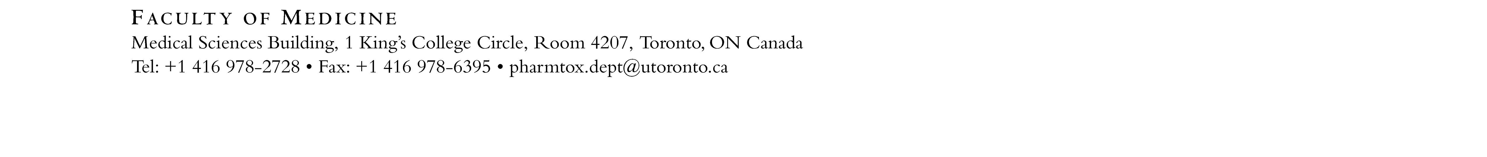

Assistant Invigilator Application Form 2019-2020

Graduate students wishing to invigilate the examinations offered by the Department of Pharmacology should complete this form and return it with a cover letter to undergrad.pharmtox@utoronto.ca.

The names of all qualified applicants will be drawn in random order and added to a list of invigilators. Invigilators will be contacted (in order of the invigilator list) in advance of examinations for which they will be required.

Applicant Name: | Email Address:
Home Phone: | Work Phone:
University Address:

Department: | Program:  Master’s Doctoral
Year in Program: | Current Supervisor:
Preferred Method of Contact:

Home Phone Work Phone Email

If any of the above information changes, please notify the Department (undergrad.pharmtox@utoronto.ca).

