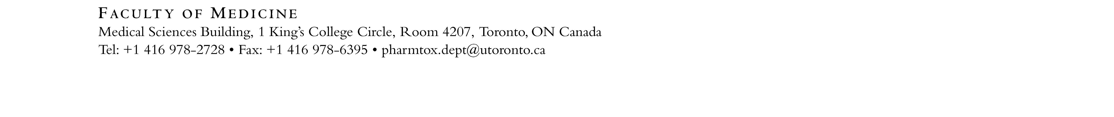

Laboratory Demonstrator Application Form 2021-2022

Applicant Name: |  | Student Number:
Email: |  | Phone Number:
Department: |  | Program:  Undergrad MSc PhD Postdoc
Year in Program (as of September 2021): |  | Research Supervisor (if applicable):
Position(s) applied for (please rank in order of preference):
1. | 2.
What is your background experience in Pharmacology and/or Toxicology? Please include relevant coursework.

Which of the following techniques are you familiar with? Please check all that apply:

Cell culture techniques | Trypan Blue assay |  | MTS assay
Alamar Blue assay | DNA, protein and RNA isolation |  | Western blot
qPCR, PCR | Restriction enzyme digest |  | Flow cytometry
BRET assay | PDE activity assay |  | Liver microsomes preparation
HPLC Data analysis | Drug metabolism |  | Pharmacokinetics in mice and/or in human – data quantification by HPLC
Mouse handling: IP injection, saphenous vein bleeding, blood plasma processing | Human behavioural studies – questionnaire and battery of human behavioural tests |  | Behavioral testing in mice-locomotor activity and elevated plus maze
Genotyping | Statistical data analysis of human data |  | Other (please specify):
Please submit the following documents in a single PDF file to: undergrad.pharmtox@utoronto.ca
Application Form
Cover Letter
Résumé / CV
Academic Transcripts (web printouts are acceptable)

The University of Toronto is strongly committed to diversity within its community and especially welcomes applications from visible minority group members, women, Aboriginal persons, persons with disabilities, members of sexual minority groups, and others who may contribute to the further diversification of ideas.

