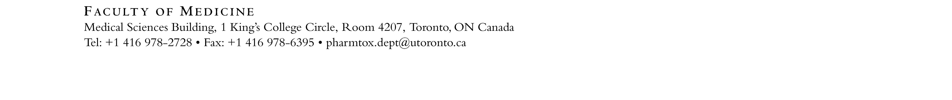

Lecture Based Teaching Assistantship Application Form 2021-2022

Applicant Name: |  | Student Number:
Email: |  | Phone Number:
Department: |  | Program:  Undergrad MSc PhD Postdoc
Year in Program (as of September 2021): |  | Research Supervisor (if applicable):
Position(s) applied for (please rank in order of preference):

1. | 2. |  | 3.
What is your background experience in Pharmacology and/or Toxicology? Please include relevant coursework.

Which of the following areas do you have experience with? Please check all that apply:

Behavioural Pharmacology | Biochemical/Molecular Pharmacology |  | Cardiovascular Pharmacology
Clinical Pharmacology | Co-op / PEY / Professionalism |  | Drug Metabolism
Endocrine Pharmacology | Immunopharmacology |  | Pharmacokinetics
Receptor Pharmacology | Signal Transduction |  | Toxicology
Other (please specify):
Please submit the following documents in a single PDF file to: undergrad.pharmtox@utoronto.ca
Application Form
Cover Letter
Résumé / CV
Academic Transcripts (web printouts are acceptable)

The University of Toronto is strongly committed to diversity within its community and especially welcomes applications from visible minority group members, women, Aboriginal persons, persons with disabilities, members of sexual minority groups, and others who may contribute to the further diversification of ideas.

